Moving Tables
Time Limit: 1000MS |  | Memory Limit: 10000K
Total Submissions: 15130 |  | Accepted: 4947
Description
The famous ACM (Advanced Computer Maker) Company has rented a floor of a
先进的 租用的
building whose shape is in the following figure.
使符合 数字
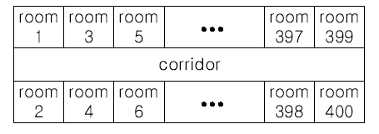
走廊
The floor has 200 rooms each on the north side and south side along the corridor. Recently the Company made a plan to reform its system. The reform includes moving
最近 改良
a lot of tables between rooms.
Because the corridor is narrow and all the tables are big, only one table can pass
狭隘的
through the corridor. Some plan is needed to make the moving efficient. The manager
有效率的
figured out the following plan: Moving a table from a room to another room can be done within 10 minutes. When moving a table from room i to room j, the part of the
在…之内
corridor between the front of room i and the front of room j is used. So, during each 10 minutes, several moving between two rooms not sharing the same part of the
共享
corridor will be done simultaneously. To make it clear the manager illustrated the
同时地 有插图的
possible cases and impossible cases of simultaneous moving.
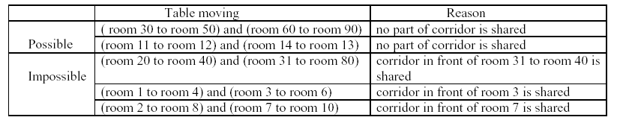
For each room, at most one table will be either moved in or moved out. Now, the
对于每一个房间，最多只有一张桌子允许被移入或移出
ger seeks out a method to minimize the time to move all the tables. Your job is to
寻找 方法 减到最小
write a program to solve the manager's problem.
Input
The input consists of T test cases. The number of test cases T is given in the first line of the input file. Each test case begins with a line containing an integer N ,
包含
1 <=N <= 200, that represents the number of tables to move.
描绘
Each of the following N lines contains two positive integers s and t, representing that a table is to move from room number s to room number t each room number appears
在N行输入中每个房间最多出现一次
at most once in the N lines. From the 3 + N -rd
line, the remaining test cases are listed in the same manner as above.
剩下的
Output
The output should contain the minimum time in minutes to complete the moving, one
完整的
per line.

Sample Input
3 要做这个实验3次
4 第一次实验，移动4次
10 20
30 40
50 60
70 80
2 第二次实验，移动2次
1 3
2 200
3 第三次实验，移动3次
10 100
20 80
30 50
Sample Output
10 每次实验所用的最短时间
20
30
Source
Taejon 2001

